EXP NO 13 : PERFORMANCE EVALUATION OF DENSE WDM
MULTIPLEXING AND DEMULTIPLEXING USING
OPTISYSTEM

OBJECTIVES
1. To design and simulate a Dense Wavelength Division Multiplexing (DWDM)
optical communication system using OptiSystem.
2. To investigate the impact of varying optical fiber length on overall system
performance.
3. To examine the effectiveness of an Erbium-Doped Fiber Amplifier (EDFA) in
compensating for fiber ajenuation losses.
4. To evaluate and compare received power, bit error rate (BER), and Q-factor
across different fiber lengths.

SOFTWARE REQUIRED
• Optisystem software

PROCEDURE
1. Open OptiSystem and create a new project.
2. Generate four optical channels using PRBS, NRZ pulse generator and CW
lasers.
3. Set different wavelengths with 100 GHz channel spacing.
4. Combine the channels using a WDM Multiplexer.
5. Connect the multiplexed signal to an Optical Fiber.
6. Place an EDFA amplifier after the fiber to compensate for ajenuation.
7. Connect a WDM Demultiplexer at the receiver.
8. Use PIN photodetectors, low-pass filters and BER analyzers for each channel.
9. Repeat the simulation for 10, 20, 30 and 40 km fiber lengths.
10. Compare received power, Q-factor and BER with and without amplification.

BLOCK DIAGRAM
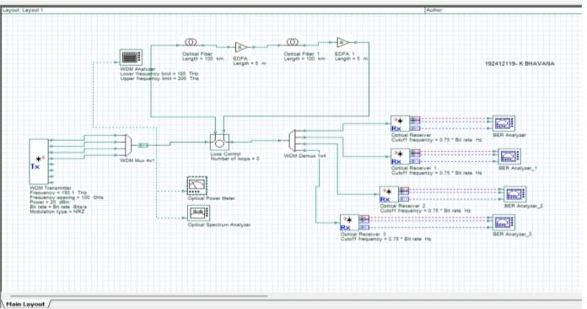

OUTPUT
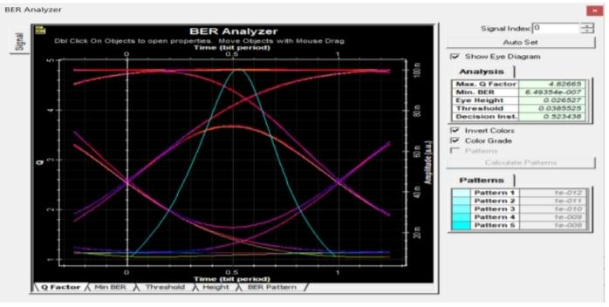
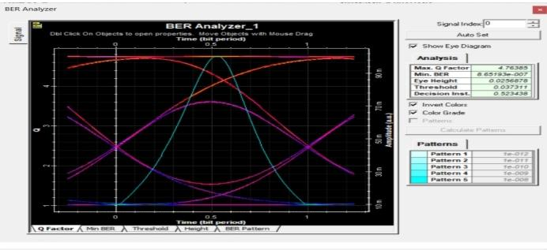
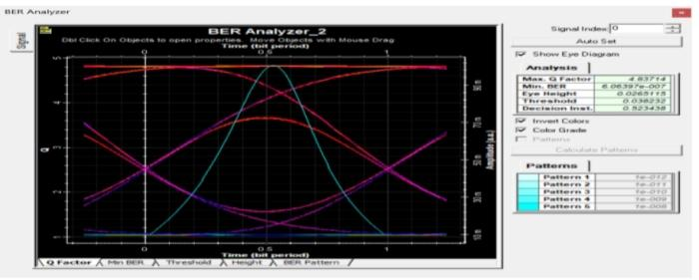
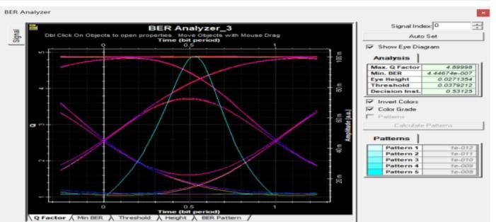
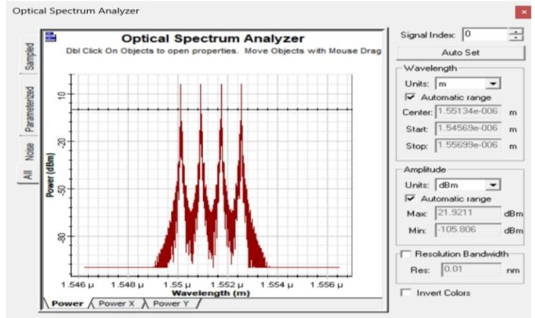

REFLECTION
This experiment helped me understand DWDM technology and learn how multiple optical signals are transmitted through a single fiber using multiplexing and demultiplexing techniques.

LABORATORY PERFORMANCE ASSESSMENT RUBRIC
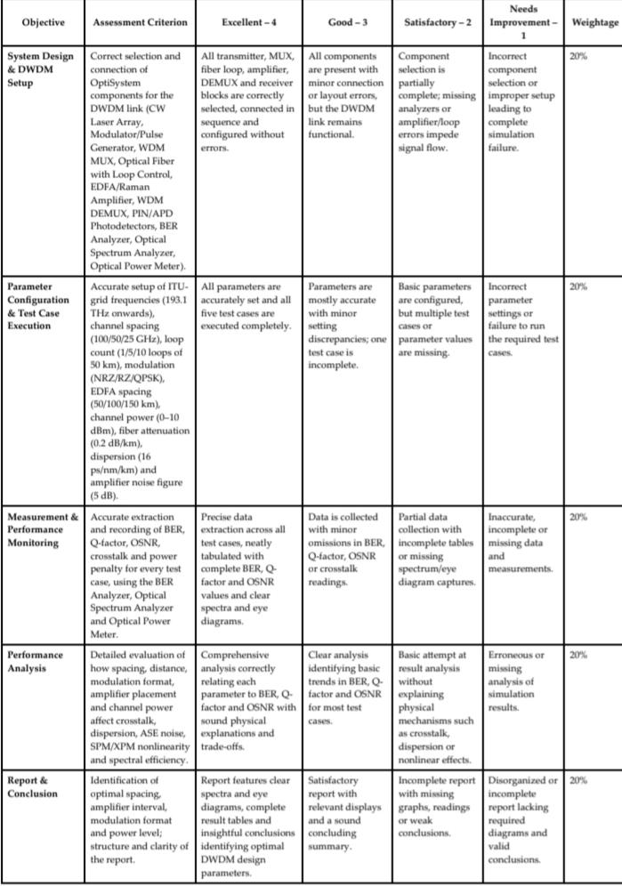

RESULT
The DWDM system with EDFA was analyzed for varying fiber lengths. Longer fibers
increase attenuation and degrade the signal, while the EDFA compensates for this
loss, improving received power, Q-factor, and BER. This confirms DWDM with
optical amplification is suitable for high-capacity, long-distance communication.

